Frontend Development with React.js Great Recipes Documentation .

# Introduction

* + Project Title: Great Recipes
  + Team Members:
    - Dhanush Kumar D - Team Leader
    - Ajay Daniel P
    - Gokulan S
    - Danush SV
    - Prince Martin

# Project Overview

* + Purpose: The Great Recipes project aims to provide users with a platform to discover, share, and manage a variety of recipes. The goal is to create an engaging and

user-friendly experience for cooking enthusiasts.

* + Features:
    - User authentication and profile management
    - Recipe search and filtering options
    - User-generated content for sharing recipes
    - Rating and commenting system for recipes
    - Responsive design for mobile and desktop users

# Architecture

* + Component Structure:
    - Major components include:
      * App
      * Navbar
      * RecipeList
      * RecipeDetail
      * UserProfile
    - Components interact through props and state management.
  + State Management:
    - The project uses Redux for global state management to handle user authentication and recipe data.
  + Routing:
    - React Router is used to manage navigation between different pages such as Home, Recipe Detail, and User Profile.

1. Setup Instructions
   * Prerequisites:
2. Node.js (version 14 or higher)
3. npm (Node package manager)
   * Installation:
4. Clone the repository: git clone https://github.com/Gokulan08/Great-Recipes.git
5. Navigate to the project directory: cd Great-Recipes
6. Install dependencies: npm install
7. Configure environment variables as needed.

# Folder Structure

* + Client:
    - The React application is organized as follows:
      * src/components: Contains reusable components.
      * src/pages: Contains page components.
      * src/styles: Contains CSS files for styling.
      * src/images: Contains image assets.
  + Utilities:
    - Helper functions and custom hooks are located in src/utils.

# Running the Application

* + Commands:
    - To start the frontend server locally, run: npm start in the client directory.

# Component Documentation

* + Key Components:
    - App: The main component that renders the application.
    - Navbar: Navigation bar for routing.
    - RecipeList: Displays a list of recipes.
    - RecipeDetail: Shows detailed information about a selected recipe.
  + Reusable Components:
    - Button: A reusable button component that accepts props for customization.

# State Management

* + Global State:
    - Redux is used to manage the global state, allowing for easy access to user and recipe data across components.
  + Local State:
    - Local state is managed using React's useState hook within individual components.

# User Interface

* + 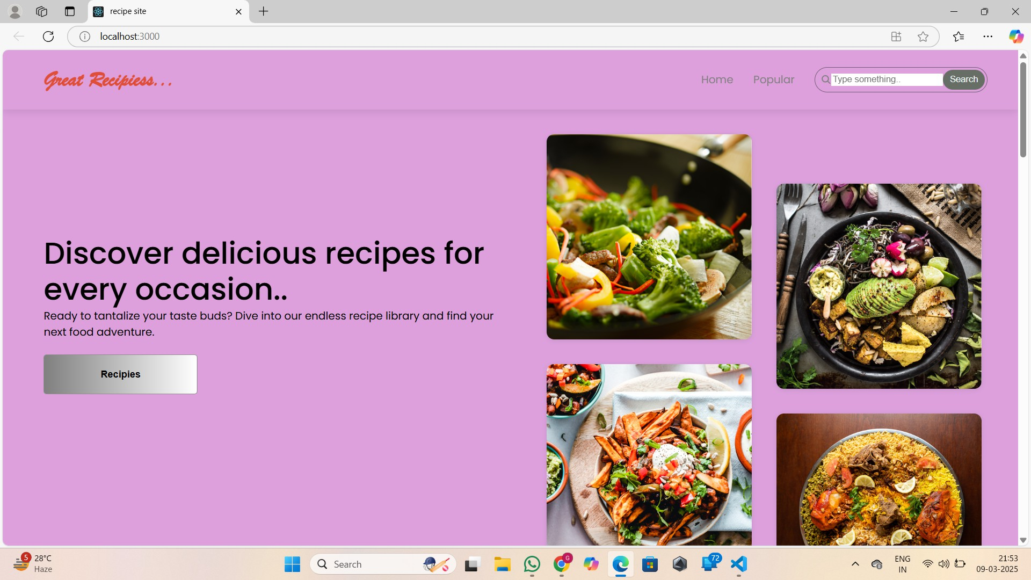Visuals: Screenshots of showcasing the UI features, such as the homepage, recipe detail page, and user profile.

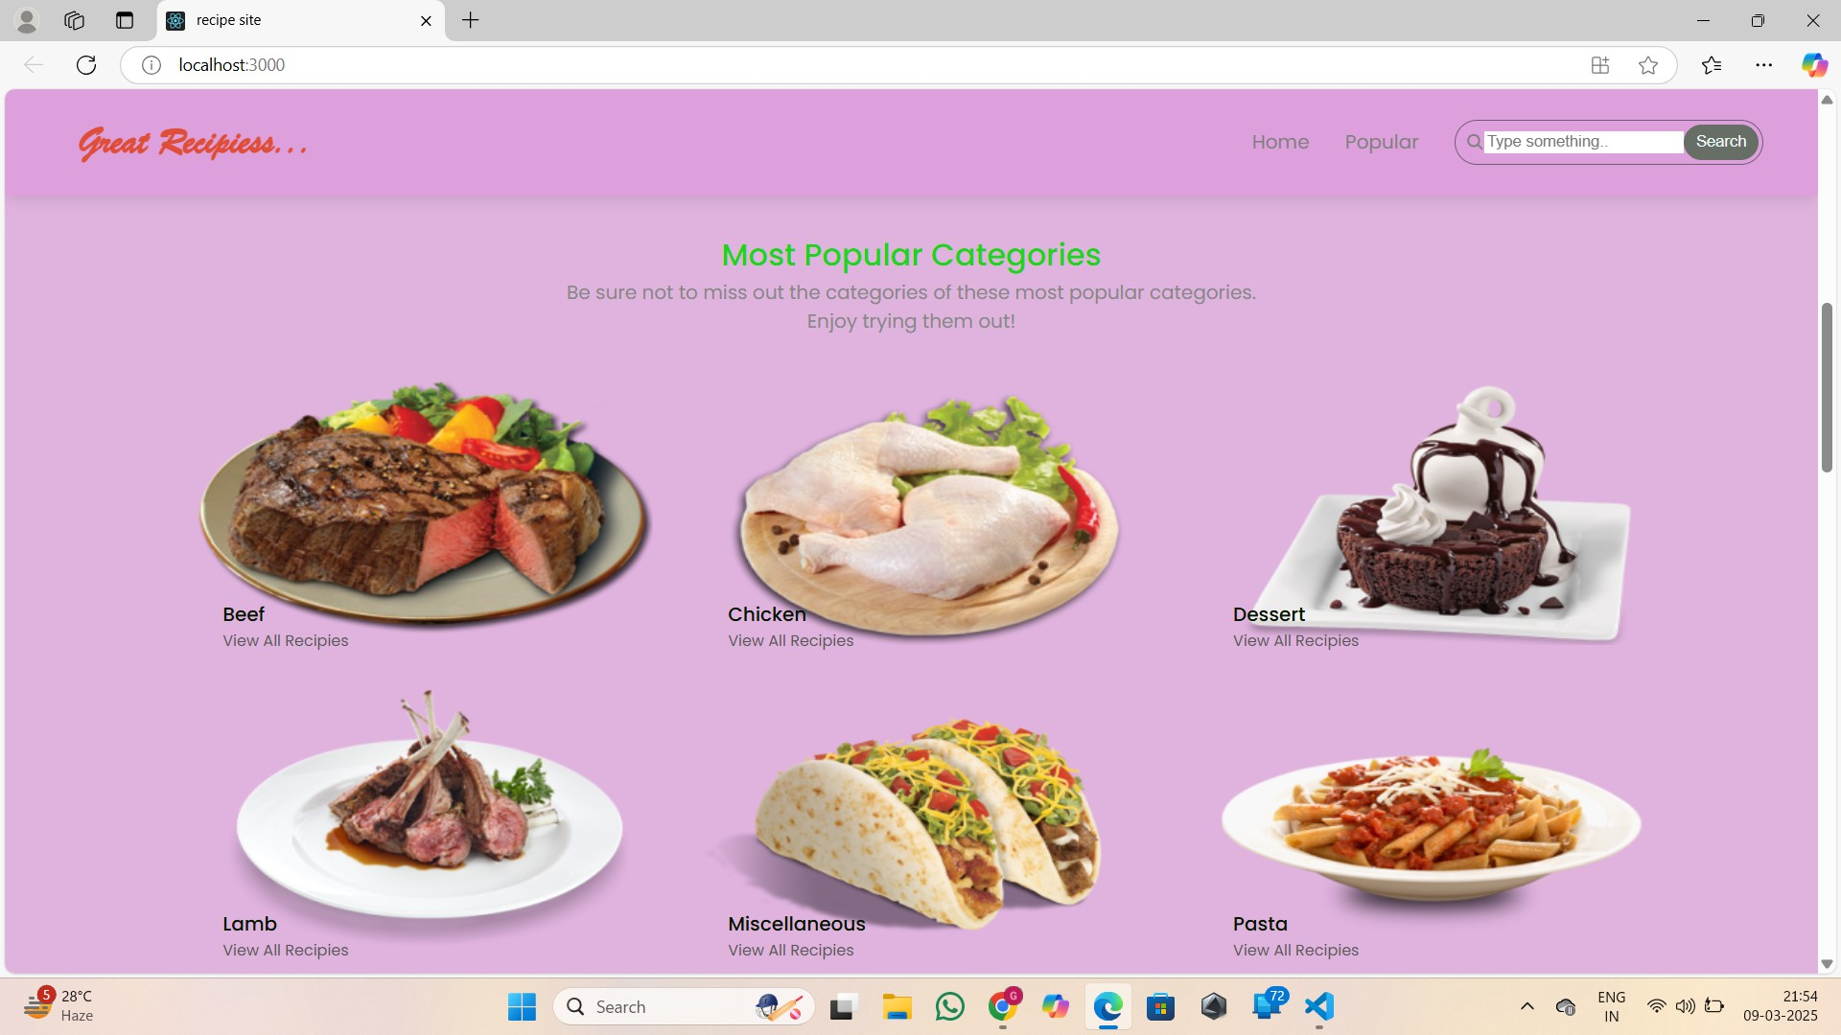

# Styling

* + CSS Frameworks/Libraries:
    - The project uses Styled-Components for styling components.
  + Theming:
    - A custom design system is implemented to maintain consistency across the application.

# Testing

* + Testing Strategy:
    - The project employs unit testing using Jest and React Testing Library for component testing.
  + Code Coverage:
    - Code coverage is monitored using Jest's built-in coverage tool.

# Screenshots

* + Visuals: Provide screenshots or a link to a demo showcasing the application’s features and design.

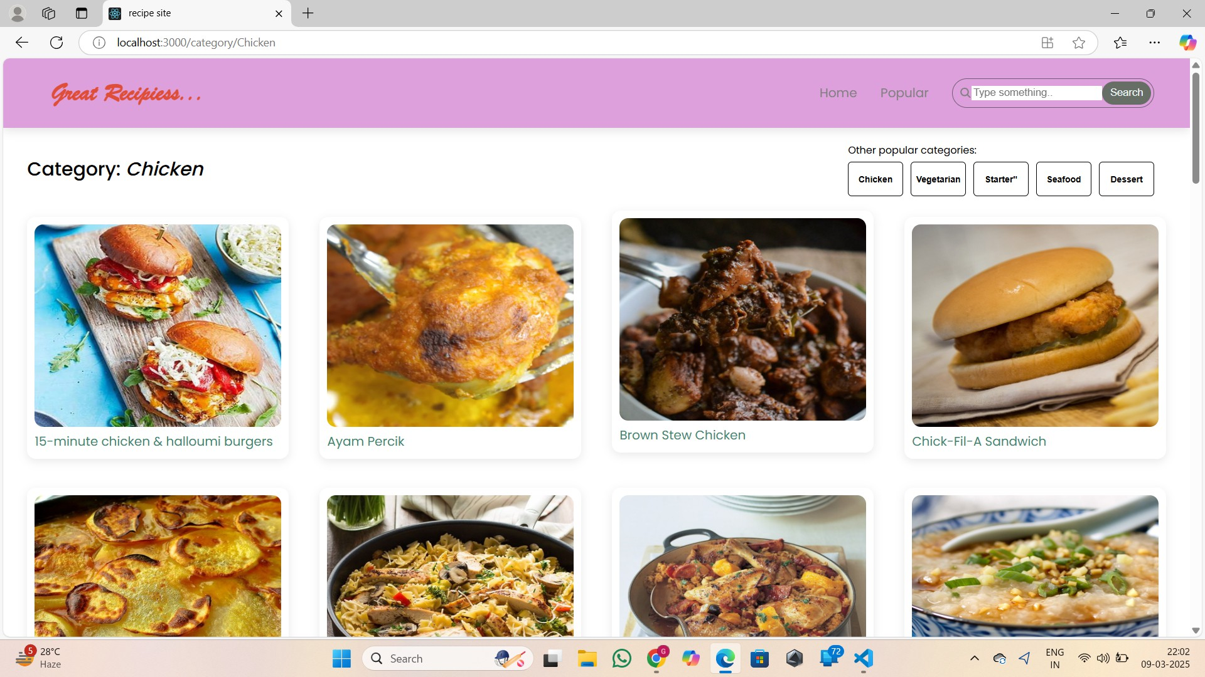

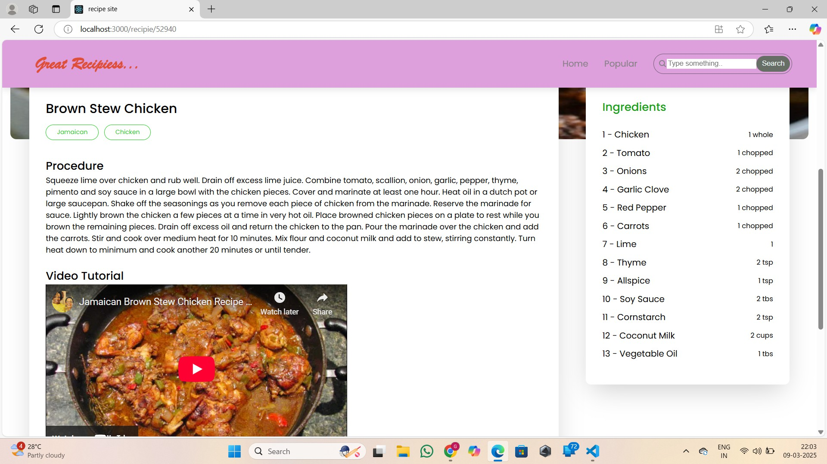

# Known Issues

* + Bugs:
    - Document any known bugs or issues that users or developers should be aware of, such as:
      * Recipe search may return incomplete results.
      * User profile updates may not reflect immediately.

# Future Enhancements

* + Improvements:
    - Potential future features include:
      * Adding a meal planning feature.
      * Implementing a shopping list generator based on selected recipes.
      * Enhancing the user interface with animations and transitions.